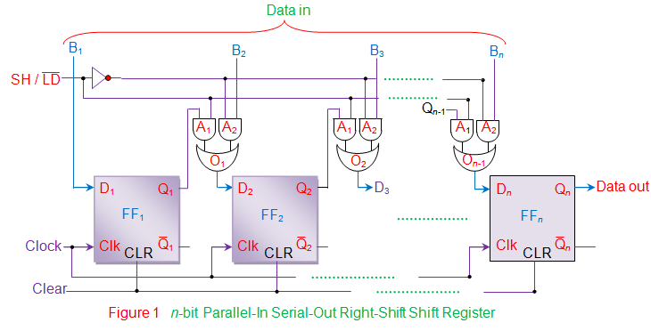
Figure 1. An n-bit Parallel-In Serial-Out Right-Shift Register. In PISO shift registers, the data is loaded into the register in parallel format while it is retrieved from it serially.

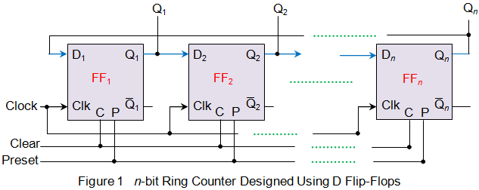
Figure 2. An n-bit Ring Counter

module PISO_RSHIFT (CLK, CLR, SHL, DIN, Q);

input CLK, CLR, SHL;
input [7:0] DIN;
output Q;
reg Q;
reg [7:0] SHIFTER;

always @ (posedge CLK)
if (CLR)
SHIFTER = 8'b0;
else
if (~SHL)
SHIFTER = DIN;
else
begin
Q = SHIFTER[0];
SHIFTER = {1'b0, SHIFTER[7:1]};
end

endmodule

module test_PISO_RSHIFT;

reg CLK, CLR, SHL;
reg [7:0] DIN;
wire Q;

PISO_RSHIFT s1 (CLK, CLR, SHL, DIN, Q);

always
#5 CLK = ~CLK;

initial
begin
CLK = 1'b0;
CLR = 1'b1;
DIN = 8'b10101101;
#10 CLR = 1'b0;
#5 SHL = 1'b0;
#6 SHL = 1'b1;
end

endmodule

